**The Almond Festival**

While [Morocco’s](https://www.intrepidtravel.com/en/morocco) most widely celebrated festivals are Islamic, the focus on food, family and community (plus legendary Moroccan hospitality) makes it easy for anyone to get involved in the celebrations. Just keep in mind that they are based on a lunar calendar, which means the dates change every year. In addition to these religious holidays, Morocco has a number of unique cultural festivals that offer insight into the ancient traditions of the land.

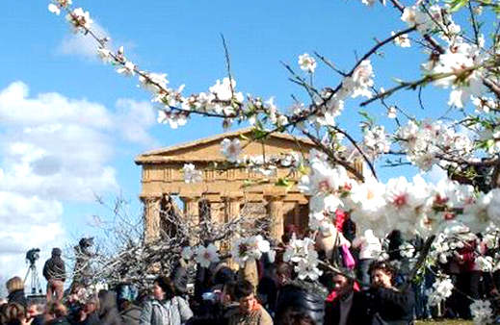

The Almond Blossom Festival is held in Tafraoute to honour the transformation of the landscape during the annual blooming of almond tree flowers, as well as the cultural traditions of the Amazigh (Berber) folks who live here. Visit this tiny town for musical and cultural performances, Amazigh hospitality and some very creative recipes involving almonds. Usually held in the second week of February.